featured

Preserving Haverhill history

Rocks Village neighbors renovate area's centerpiece
- By Mike LaBella mlabella@eagletribune.com
- Nov 1, 2016

https://www.facebook.com/sharer/sharer.php?u=http://www.eagletribune.com/news/haverhill/preserving-haverhill-history/article_24f43a6a-6fef-5bb0-b2d4-e1e20db8cac6.htmlhttps://twitter.com/intent/tweet?text=http://www.eagletribune.com/news/haverhill/preserving-haverhill-history/article_24f43a6a-6fef-5bb0-b2d4-e1e20db8cac6.html %7C Preserving Haverhill historyhttps://plus.google.com/share?url=Preserving Haverhill history http://www.eagletribune.com/news/haverhill/preserving-haverhill-history/article_24f43a6a-6fef-5bb0-b2d4-e1e20db8cac6.htmlhttp://www.linkedin.com/shareArticle?mini=true&url=http://www.eagletribune.com/news/haverhill/preserving-haverhill-history/article_24f43a6a-6fef-5bb0-b2d4-e1e20db8cac6.html&summary=Preserving Haverhill historyhttp://pinterest.com/pin/create/button/?url=http://www.eagletribune.com/news/haverhill/preserving-haverhill-history/article_24f43a6a-6fef-5bb0-b2d4-e1e20db8cac6.html&media=http://bloximages.chicago2.vip.townnews.com/eagletribune.com/content/tncms/assets/v3/editorial/7/57/7579adab-b633-5921-9966-2d59c53681f5/58180fc19601e.image.jpg?resize=760%2C504&description=Preserving Haverhill historymailto:?subject=Preserving Haverhill history&body=http://www.eagletribune.com/news/haverhill/preserving-haverhill-history/article_24f43a6a-6fef-5bb0-b2d4-e1e20db8cac6.html
HAVERHILL — It started with a dream, and that dream is close to becoming reality — there is still more to do.
The historic Hand Tub House that once helped protect homes in Rocks Village is itself being protected for the use and enjoyment of future generations.
+6
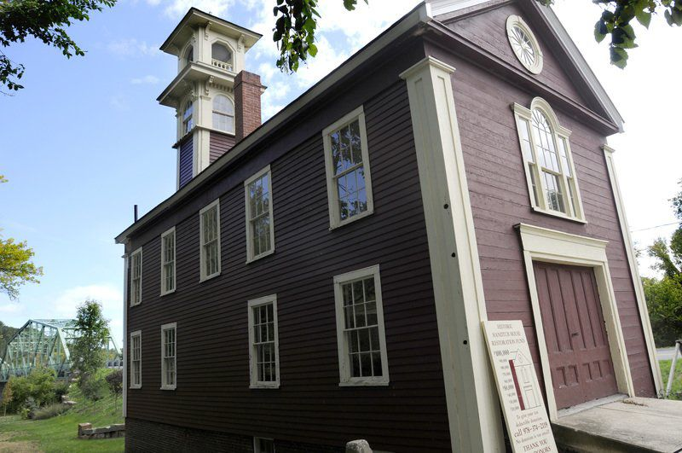
TIM JEAN/Staff photoThe Rocks Village Hand Tub House
Tim Jean
Dating back to 1840, the building that long housed a hand-pumped fire apparatus suffered from deterioration and neglect over the years.
But the ravages of time are being reversed with the help of neighbors, and now the historic building is entering its final phase of repairs.
+6
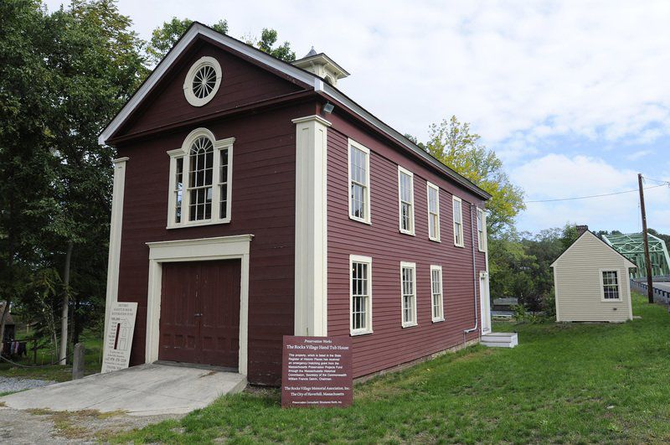
TIM JEAN/Staff photo
Members of the Rocks Village Memorial Association will be having a yard sale fundraiser to benefit the Rocks Village Hand Tub House renovations.
Tim Jean
Over the past four years, members of the Rocks Village Memorial Association have put their hearts and souls into raising money for repairs and volunteering their time to save money. Their hopes are to transform the building into a museum and cultural arts and education center.
+6
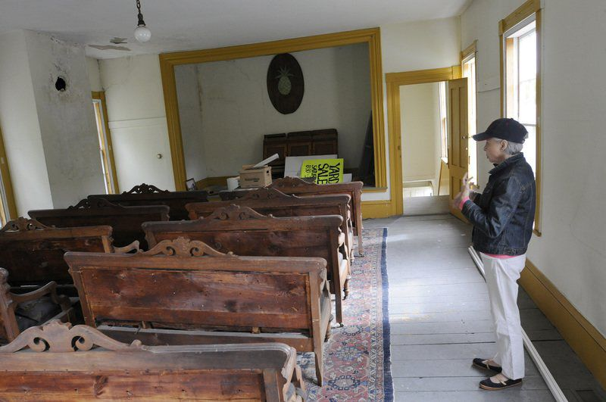
TIM JEAN/Staff photo.
Neighbor Cindy Dauksewicz looks over the old meeting room on the second floor of the Rocks Village Hand Tub House.
Tim Jean
“Since 2012, we’ve spent $70,000 in repairs to the foundation, which is now very solid,” said association member Christine Kwitchoff. “We’ve had 50 sheets of new roofing plywood installed and we’ve re-shingled the roof. We worked out a payment plan with Lambert Roofing (company) that allowed us to do the repairs properly. They were great to work with.”
+6
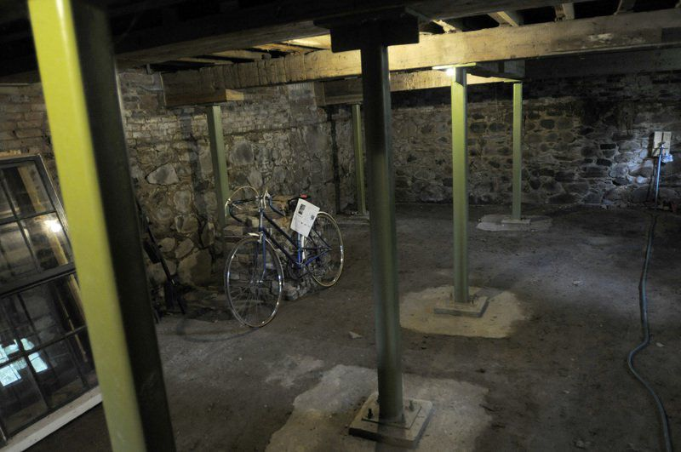
TIM JEAN/Staff photo
New steel columns and masonry have been installed in the basement of the Hand Tub House.
Tim Jean
The historic building served as a combination tub house and meeting hall during the early industrial period of the mid-1800s. It is owned by the city, but is under the stewardship of the Rocks Village Memorial Association, composed of six residents of the village.
+6
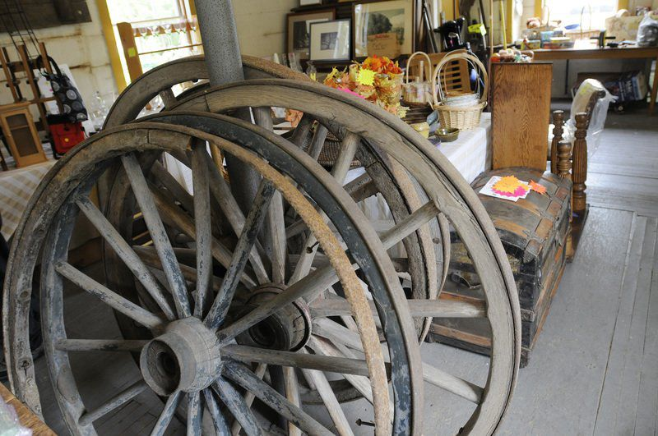
TIM JEAN/Staff photo
Historic items are kept inside the Hand Tub House.
Tim Jean
Rotted and split exterior trim boards have been replaced, as have the exterior entry platform and the staircase leading to to the second floor. Previously boarded-up basement windows were replaced with new replica windows that help maintain the historic image of the building.
“We had the old knob-and-tube wiring replaced with surface mount wiring, and we installed LED bulbs that are designed to look like old-fashioned Edison light bulbs, and we had the electrical service upgraded along with a new circuit breaker panel,’’ Kwitchoff said. “We also had surface mount receptacles installed, which are an improvement over the single receptacle we used to have and which was always blowing a fuse.”
One of the next steps is to have the building’s windows reglazed, which the group has money to do.
“We are in desperate need of repainting the exterior, but we’ll need to raise money for that,” Kwitchoff said.
+6
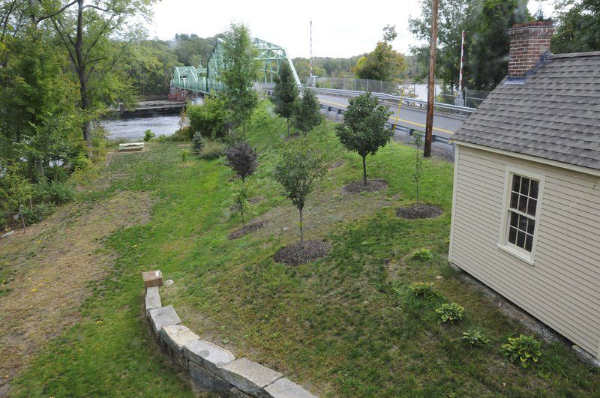
This is the view from a second-floor window of the Rocks Village historic Hand Tub House, looking toward Rocks Village Bridge.
TIM JEAN/Staff photo
Tim Jean
“People driving by see that the building does look better, but they don’t necessarily see all of the work we’ve done so far as much of it is not readily visible,” she said.
“So many people connect with this place .... It’s a well-known landmark,” said association member Kevin McCarthy. “People taking walks, people on bicycles and others often stop here to rest and enjoy the river.”
Building is village’s centerpiece
Kwitchoff said the Hand Tub House is the heart of Rocks Village. Generations ago, the neighborhood was home to businesses such as taverns that catered to sailors on ships that came up river.
“It predates all of us, but we all have a real connection to this building,” Kwitchoff said.
The old L.V. Spaulding #5 hand pump apparatus that was stationed in the Hand Tub House to protect the village is now on display at the Haverhill Firefighting Museum on Kenoza Avenue.
Structural repairs to the Hand Tub House included replacing insufficient lally columns in the cellar with permanent steel supports and erecting a thick, concrete wall along the East Main Street side of the building to prevent water runoff from entering the building as had been happening.
“The runoff from East Main Street was so bad that it eroded the brick wall mortar on the south wall,” Kwitchoff said. “We removed the brick wall and replaced it with a concrete wall with brick finish on the exterior.”
Once exterior painting and window reglazing is complete, along with minor carpentry repairs, the group plans to focus its attention on the building’s second floor, where there is a historic meeting room and what used to be a kitchen area when the building served as a fire station.
The group must raise money to pay for exterior painting and plaster repairs to second-floor walls and ceilings.
“When renovations are complete, we can use the building for more events such as meetings, historical slide show presentations, art shows and receptions, musical performances and other events,” Kwitchoff said. “We are probably two years away from that, but next spring we’d love to host our first exhibition of Rocks (Village) artists, of which there are several, and have an open house for the community.”
Bridge used by several communities
The second-floor meeting room holds 10 old fancily designed horsehair-stuffed settees the group hopes to refurbish. They also plan to repair plaster walls and ceilings that were damaged from rain entering through the old roof before it was repaired.
Landscaping has included the planting of more than a dozen trees this summer, along with many new bushes and flowering plants which have improved the aesthetics of Hand Tub Park.
A granite retaining wall that adds to the charm of the scenic little park, which stretches to the banks of the Merrimack River. The wall was built by SPS New England Inc. That company also led the $11.5 million MassDOT Accelerated Bridge Program Rocks Bridge restoration project.
The historic bridge is used by residents of Haverhill, West Newbury, Merrimac and several Southern New Hampshire towns. The 812-foot span was closed to traffic in June 2012 to allow work crews to renovate the bridge, which was reopened to traffic in the fall of 2013.
“We are all very proud of the work that has been done to the Hand Tub House and its property,” said association member Cindy Dauksewicz. “The community has been extremely supportive with donations large and small, and we continue to accept donations of any size. People see how well the work is being done and they want to be part of it.’’
To donate to the ongoing restoration of the Rocks Village Hand Tub House and to learn more about the work, visit online at rocksvillage.org.

